**Exercise 3: Assertions in JUnit Scenario:** You need to use different assertions in JUnit to validate your test results.  
  
**AssertionTest.java**

package com.example.junit5_test;

import org.junit.Test;

import static org.junit.Assert.*;

public class AssertionTest {

@Test

public void testAssertions() {

// Assert equals

assertEquals(5, 2 + 3);

// Assert true

assertTrue(5 > 3);

// Assert false

assertFalse(5 < 3);

// Assert null

assertNull(null);

// Assert not null

assertNotNull(new Object());

}

}

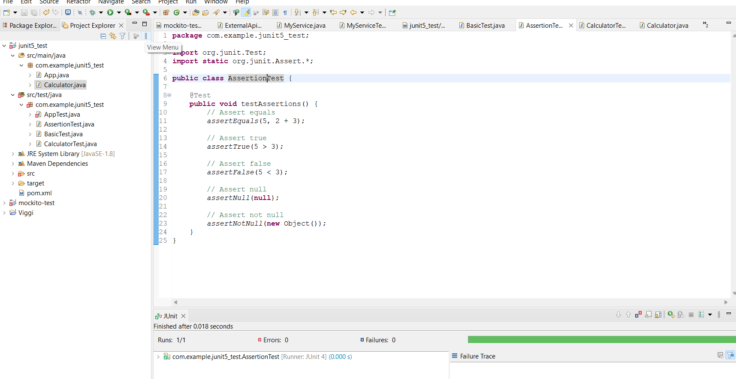**Output:**